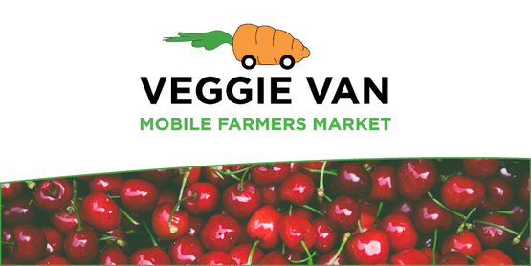**Double Up Food Bucks!!!**

Double Up Food Bucks is a program that allows you to stretch your dollars when buying fruits and vegetables with your EBT/SNAP card. For example, if you spend $10 on SNAP eligible foods at a participating location, such as a farmer’s market, mobile market, farm stand, corner store etc…, Double Up Food Bucks will give you another $10 to spend on fruits and vegetables grown in NYS.

**How does it work?**

There are different ways to earn and spend your Double Up Bucks depending on which location you choose to shop at. In Niagara County, the only place to earn and use your Double Up Bucks is at the Farmer’s Market in Lockport or the Cornell Cooperative Extension Veggie Van. There is also a participating market in Medina, The Canal Village Market, and several locations in Buffalo, such as the Lexington Co-op and the Food Plus Market. Different locations may differ from how you sign up, but the steps are primarily the same:

* Sign up
* Swipe your EBT card
* Match your SNAP/EBT dollars $2 for $2 when you purchase [SNAP-eligible foods](https://doubleupnys.com/how-it-works/)to earn FREE Double Up Food Bucks – either to be spent later or for 50% off your produce depending on the location
* 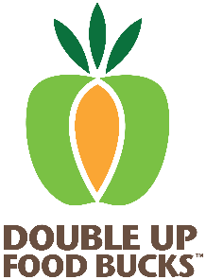Shop for [qualifying Double Up items](https://doubleupnys.com/how-it-works/)

**Double Up Food Bucks is always FREE for SNAP customers and the dollars you earn never expire*!***

To use at a farmer’s market follow these steps:

* Go to the farmer’s office info booth or office before you shop and let them know you are interested in signing up for Double Up Food Bucks
* Swipe your EBT/SNAP benefits card to receive SNAP tokens to be used in the farmer’s market
* Match your SNAP tokens $2 for $2 with Double Up Food Bucks tokens
* Shop for fresh fruits and vegetables at the market with your Double Up Food Bucks

**What is the CCE Veggie Van?**

The Veggie Van is a mobile farmer’s market that provides residents of Niagara County with access to fresh fruits and vegetables that are locally sourced. . Local produce is better nutritionally because it is picked when ripe and packed with vitamins.

The van typically travels through North Tonawanda on Tuesdays, Lockport on Wednesdays, and Niagara Falls on Thursdays and they are a participant of Double Up Food Bucks Please visit their website for a more accurate schedule:

[**http://cceniagaracounty.org/veggie-van**](http://cceniagaracounty.org/veggie-van)

Or call Cornell Cooperative Extension at **(716)-433-8839**

**Don’t forget about HEAP!**

If you applied for HEAP last year and received a regular HEAP benefit, Early Outreach Applications will be mailed out at the end of August and beginning of September. You are able to fill this application out and either mail in or drop off to the Department of Social Services before HEAP opens in November. So be on the lookout for your application!

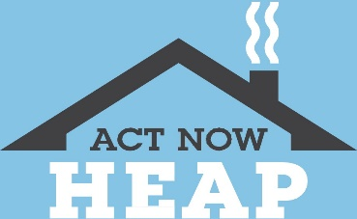

National Fuel - for more information, or to see if you qualify, visit HEAPhelps.com or call 1-877-443-2743.